**Activity 1-4**

cONSIDER this sentence: “Computers are everywhere*.” Does It Sound Like An Overstatement Or A Cliché?* No matter how you perceive the impact of computers, the statement is true. Computers ARE everywhere. In fact, you can find them in some pretty unlikely places, including your ~~family car~~, your **home appliances**, and even your alarm clock!

Activity 5

Consider this sentence: “Computers are everywhere.” Does it sound like

1. an overstatement or
2. a cliché?

No matter how you perceive the impact of computers, the statement is true. Computers are everywhere. In fact, you can find them in some pretty unlikely places, including

* your family car,
* your home appliances, and
* even your alarm clock!

Activity 6

1. Main item # 1.
   1. Sub-item 1.1.
      1. Sub-sub-item 1.1.1.
      2. Sub-sub-item 1.1.2.
   2. Sub-item 1.2.
2. Main item # 2.
3. Main item # 3.

Activity 7

FA22-BCS-057

057

cONSIDER this sentence: “Computers are everywhere*.” Does It Sound Like An Overstatement Or A Cliché?* No matter how you perceive the impact of computers, the statement is true. Computers ARE everywhere. In fact, you can find them in some pretty unlikely places, including your ~~family car~~, your **home appliances**, and even your alarm clock!

Activity 8

|  |  |  |  |
| --- | --- | --- | --- |
| Table 1 |  |  |  |
|  |  |  |  |
|  |  |  |  |

Table 2

|  |  |  |  |  |
| --- | --- | --- | --- | --- |
| Introduction | To | Information | And | Communication |
| Technologies |  |  |  |  |

Activity 9

cONSIDER this sentence: “Computers are everywhere*.” Does It Sound Like An Overstatement Or A Cliché?* No matter how you perceive the impact of computers, the statement is true. Computers ARE everywhere. In fact, you can find them in some pretty unlikely places, including your ~~family car~~, your **home appliances**, and even your alarm clock!

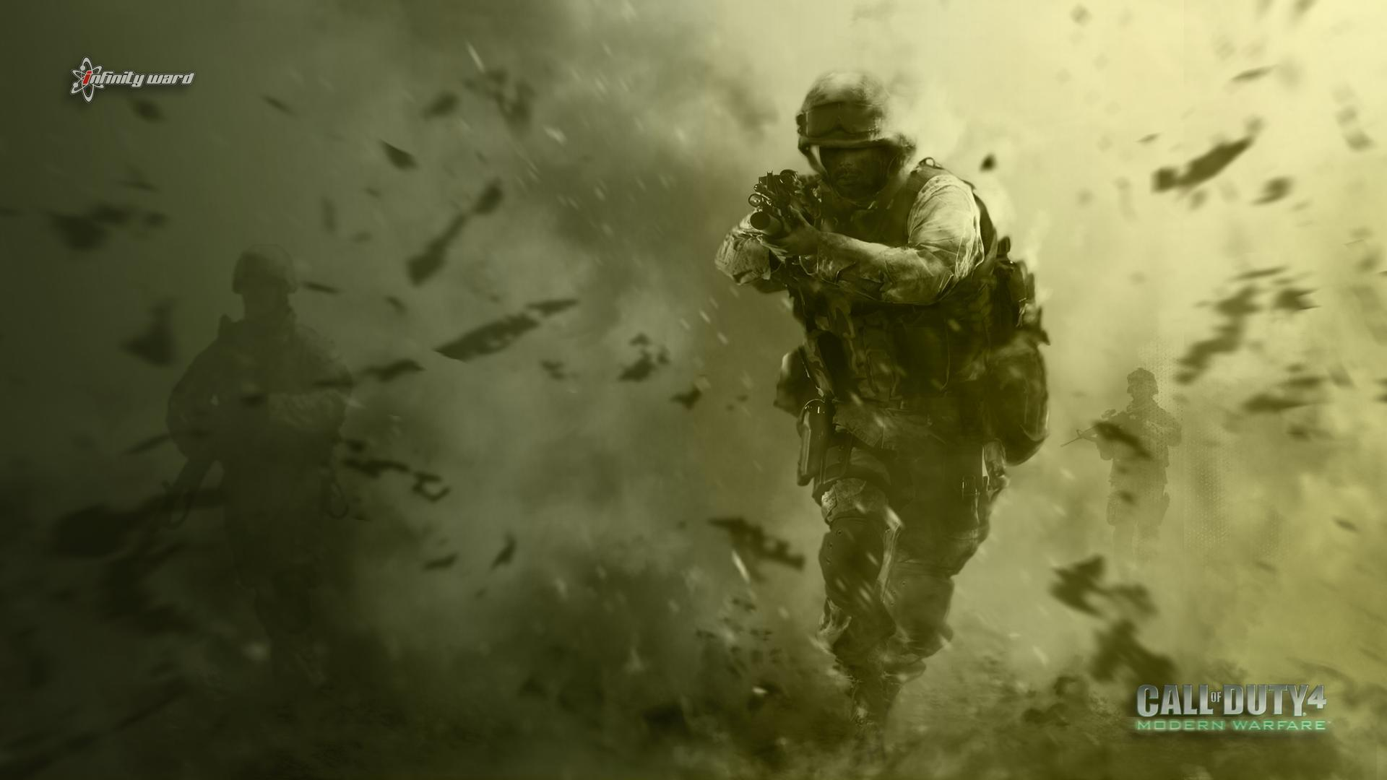

Activity 10

Hello

Activity 11

Activity 12

Activity 12

Design the layout of document pages.

Apply different themes, setup page, and page background.

**Activity 13**

Pakistan is an Asian country. There are for provinces of Pakistan. The founder of Pakistan was Quaid e Azam Muhammad Ali Jinnah. Pakistan is an Asian country. There are for provinces of Pakistan. The founder of Pakistan was Quaid e Azam Muhammad Ali Jinnah. Pakistan is an Asian country. There are for provinces of Pakistan. The founder of Pakistan was Quaid e Azam Muhammad Ali Jinnah.

Pakistan is an Asian country. There are for provinces of Pakistan. The founder of Pakistan was Quaid e Azam Muhammad Ali Jinnah. Pakistan is an Asian country. There are for provinces of Pakistan. The founder of Pakistan was Quaid e Azam Muhammad Ali Jinnah. Pakistan is an Asian country. There are for provinces of Pakistan. The founder of Pakistan was Quaid e Azam Muhammad Ali Jinnah.

Pakistan is an Asian country. There are for provinces of Pakistan. The founder of Pakistan was Quaid e Azam Muhammad Ali Jinnah. Pakistan is an Asian country. There are for provinces of Pakistan. The founder of Pakistan was Quaid e Azam Muhammad Ali Jinnah. Pakistan is an Asian country. There are for provinces of Pakistan. The founder of Pakistan was Quaid e Azam Muhammad Ali Jinnah.

Pakistan is an Asian country. There are for provinces of Pakistan. The founder of Pakistan was Quaid e Azam Muhammad Ali Jinnah. Pakistan is an Asian country. There are for provinces of Pakistan. The founder of Pakistan was Quaid e Azam Muhammad Ali Jinnah. Pakistan is an Asian country. There are for provinces of Pakistan. The founder of Pakistan was Quaid e Azam Muhammad Ali Jinnah.

**Activity 14**

Table of Contents

**Type chapter title (level 1)1**

Type chapter title (level 2)2

Type chapter title (level 3)3

**Type chapter title (level 1)4**

Type chapter title (level 2)5

Type chapter title (level 3)6

**Activity 15**

*God help those help themselves*

# Works Cited

Danyal. (2022).). *Introduction to ICT*

*ICT.* Islamabad: FA22-BCS-057.

**Activity 16**

# Bibliography

D, James. (1999). *Introduction to ICT.* Germany: Redspot.

Kramer. (2000). *xxx.* Chicago: work press.

rana, D. (2022). *ICT.* Islamabad: FA22-BCS-057.